**Problem 1: Scan conversion of a point.**

**Source Code:**

#include<graphics.h>

#include<conio.h>

#include<bits/stdc++.h>

using namespace std;

int main()

{

int gd = DETECT, gm;

initgraph(&gd, &gm, "C:\\TC\\BGI");

float x = 200, y = 200;

putpixel (x, y, WHITE);

getch();

closegraph();

return 0;

}

**Output:**

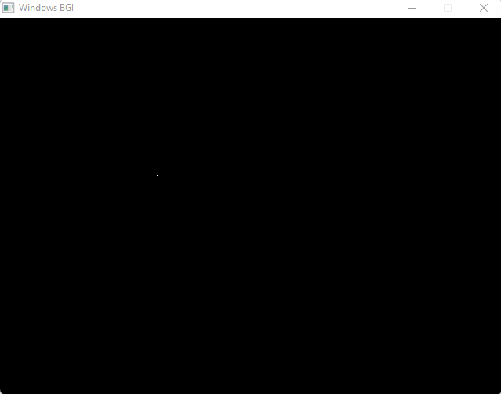

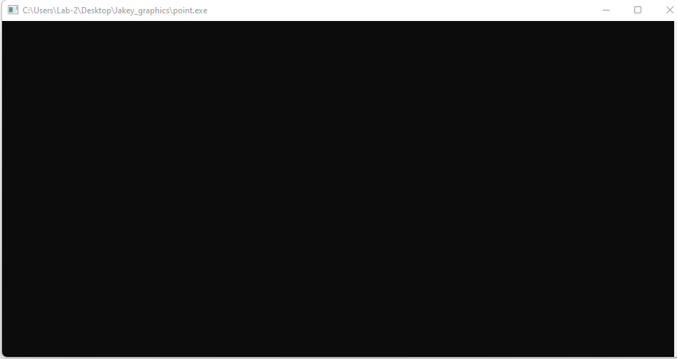

**Problem 2: Scan Conversion of a line using DDA Algorithm**

**Source Code:**

#include<graphics.h>

#include<conio.h>

#include<stdio.h>

int main()

{

int gd = DETECT ,gm, i;

float x, y,dx,dy,steps;

int x0, x1, y0, y1;

initgraph(&gd, &gm, "C:\\TC\\BGI");

setbkcolor(WHITE);

x0 = 100 , y0 = 200, x1 = 500, y1 = 300;

dx = (float)(x1 - x0);

dy = (float)(y1 - y0);

if(dx>=dy)

{

steps = dx;

}

else

{

steps = dy;

}

dx = dx/steps;

dy = dy/steps;

x = x0;

y = y0;

i = 1;

while(i<= steps)

{

putpixel(x, y, WHITE);

x += dx;

y += dy;

i=i+1;

}

getch();

closegraph();

}

**Output:** 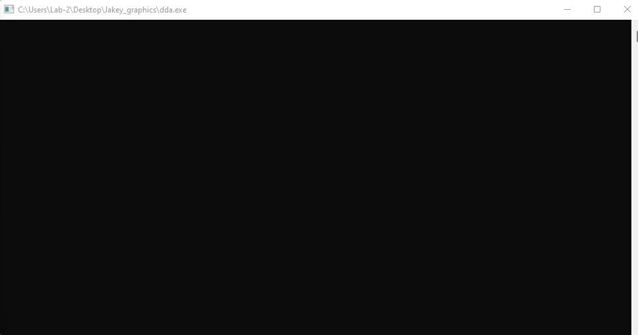

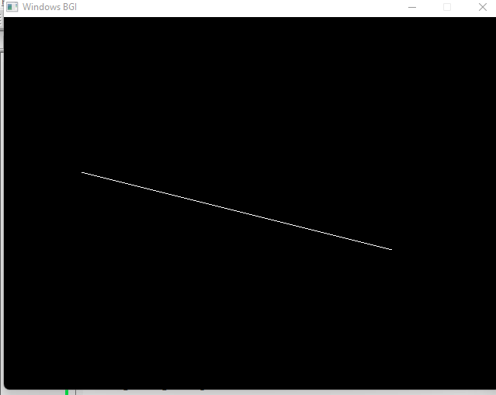

**Problem 3: Scan Conversion of line using Bresenham Algorithm**

**Source Code:**

#include<stdio.h>

#include<graphics.h>

#include<bits/stdc++.h>

void drawline(int x0, int y0, int x1, int y1)

{

int dx, dy, p, x, y;

dx=x1-x0;

dy=y1-y0;

x=x0;

y=y0;

p=2*dy-dx;

while(x<x1)

{

if(p>=0)

{

putpixel(x,y,7);

y=y+1;

p=p+2*dy-2*dx;

}

else

{

putpixel(x,y,7);

p=p+2*dy;}

x=x+1;

}

}

int main()

{

int gd = DETECT, gm;

initgraph(&gd, &gm, "C:\\TC\\BGI");

int error, x0, y0, x1, y1;

// initgraph(&gdriver, &gmode, "c:\\turboc3\\bgi");

printf("Enter co-ordinates of first point: ");

scanf("%d%d", &x0, &y0);

printf("Enter co-ordinates of second point: ");

scanf("%d%d", &x1, &y1);

drawline(x0, y0, x1, y1);

getch();

return 0;

}

**Output:**

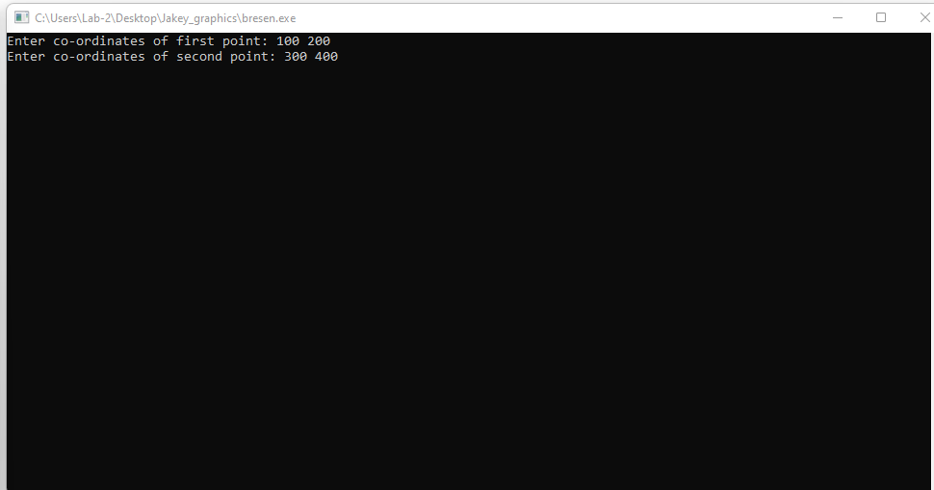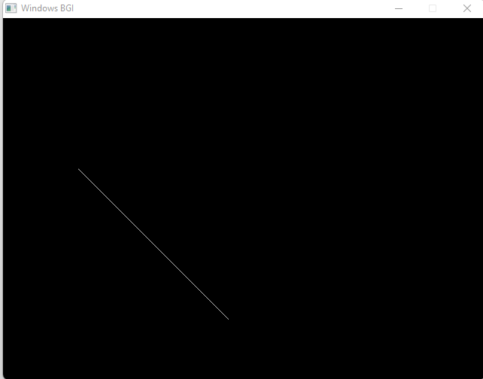

**Problem 4: Scan Conversion of circle using bresenhen Algorithm**

**Source Code:**

#include <graphics.h>

#include <stdlib.h>

#include <stdio.h>

#include <conio.h>

#include <math.h>

void EightWaySymmetricPlot(int xc,int yc,int x,int y)

{

putpixel(x+xc,y+yc,RED);

putpixel(x+xc,-y+yc,YELLOW);

putpixel(-x+xc,-y+yc,GREEN);

putpixel(-x+xc,y+yc,YELLOW);

putpixel(y+xc,x+yc,12);

putpixel(y+xc,-x+yc,14);

putpixel(-y+xc,-x+yc,15);

putpixel(-y+xc,x+yc,6);

}

void BresenhamCircle(int xc,int yc,int r)

{

int x=0,y=r,d=3-(2*r);

EightWaySymmetricPlot(xc,yc,x,y);

while(x<=y)

{

if(d<=0)

{

d=d+(4*x)+6;

}

else

{

d=d+(4*x)-(4*y)+10;

y=y-1;

}

x=x+1;

EightWaySymmetricPlot(xc,yc,x,y);

}

}

int main(void)

{

/* request auto detection */

int xc,yc,r,gdriver = DETECT, gmode, errorcode;

/* initialize graphics and local variables */

initgraph(&gdriver, &gmode, "C:\\TURBOC3\\BGI");

/* read result of initialization */

errorcode = graphresult();

if (errorcode != grOk) /* an error occurred */

{

printf("Graphics error: %s\n", grapherrormsg(errorcode));

printf("Press any key to halt:");

getch();

exit(1); /* terminate with an error code */

}

printf("Enter the values of xc and yc :");

scanf("%d%d",&xc,&yc);

printf("Enter the value of radius :");

scanf("%d",&r);

BresenhamCircle(xc,yc,r);

getch();

closegraph();

return 0;

}

**Output:**

